
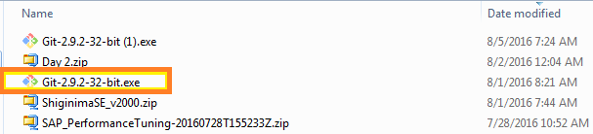
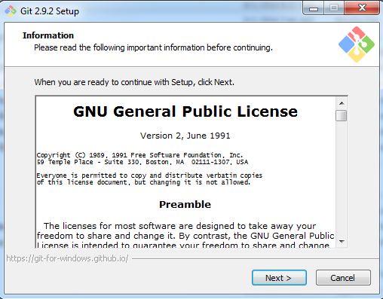
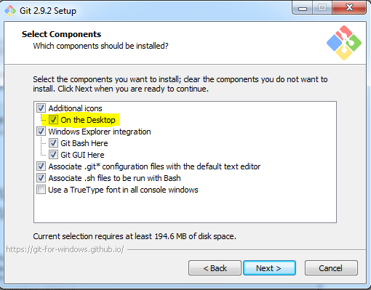
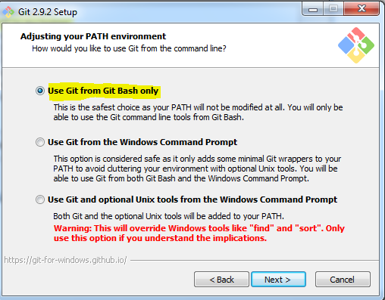
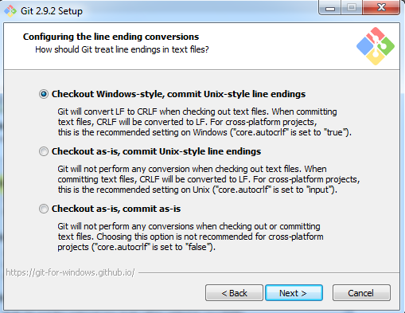
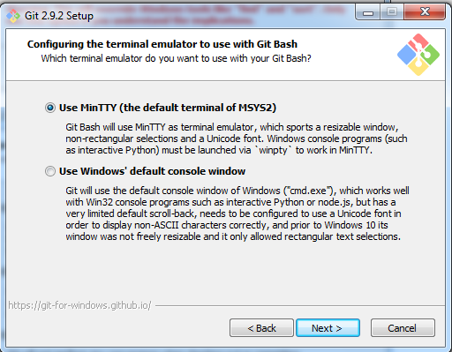
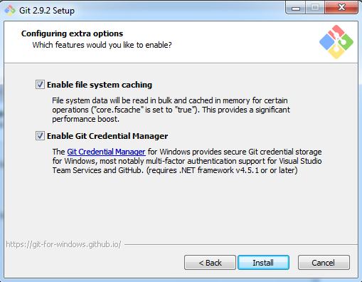
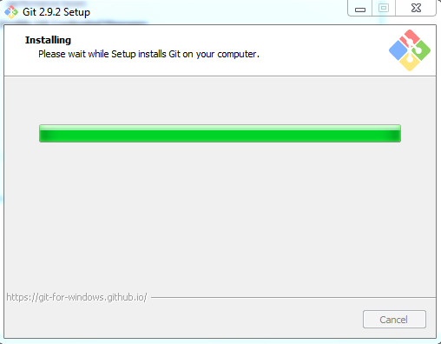
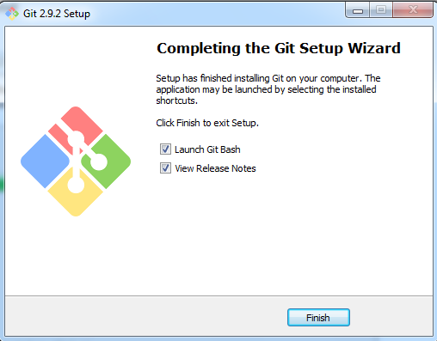
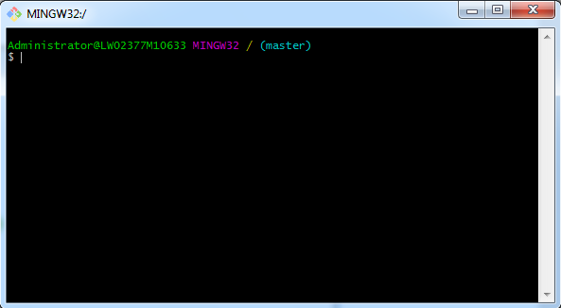

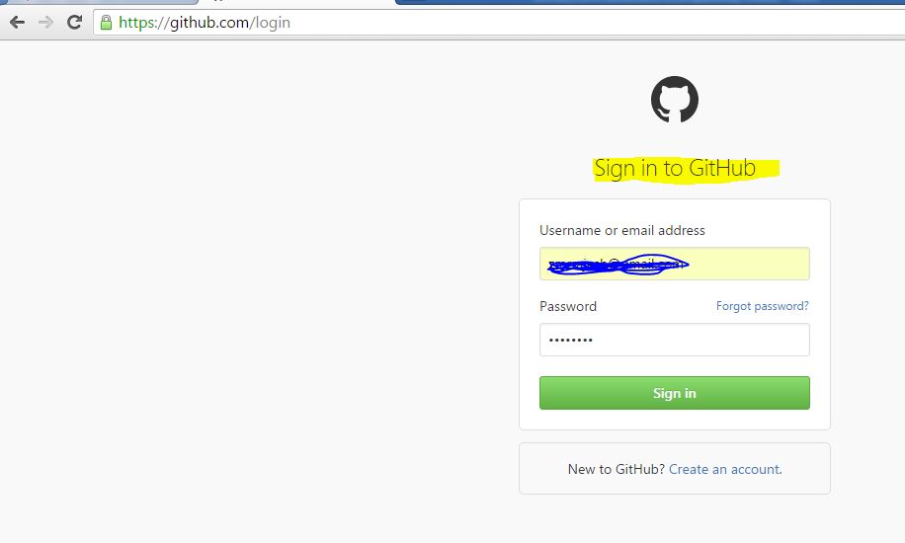
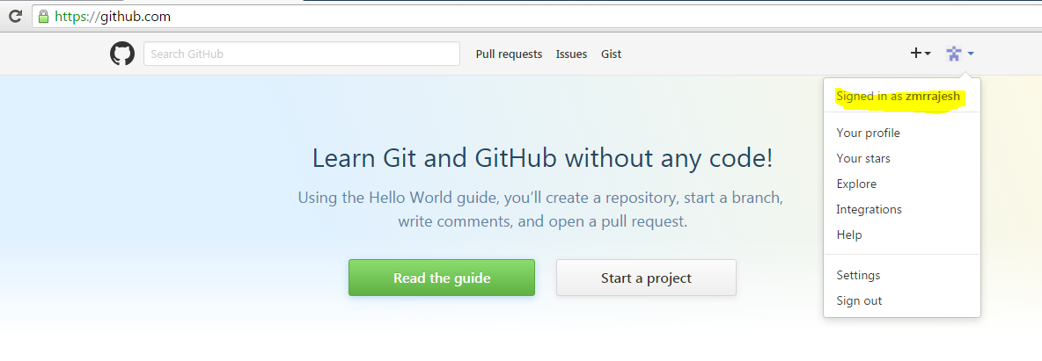
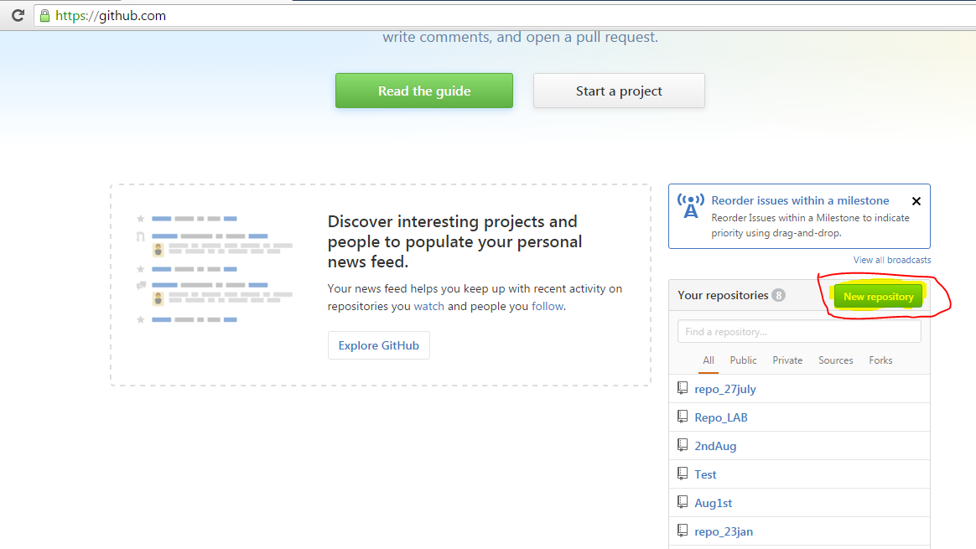
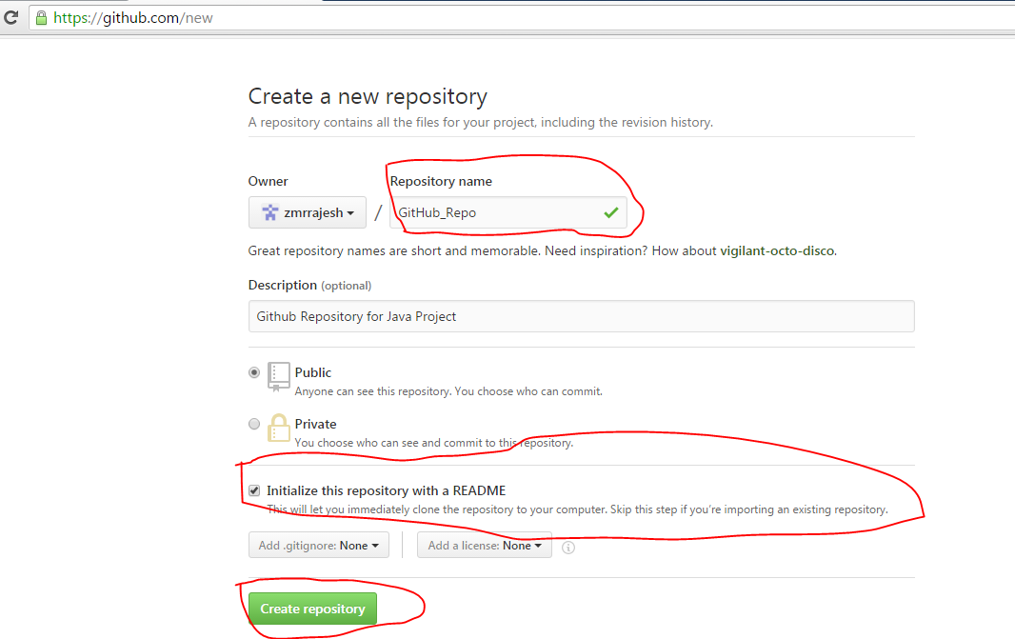
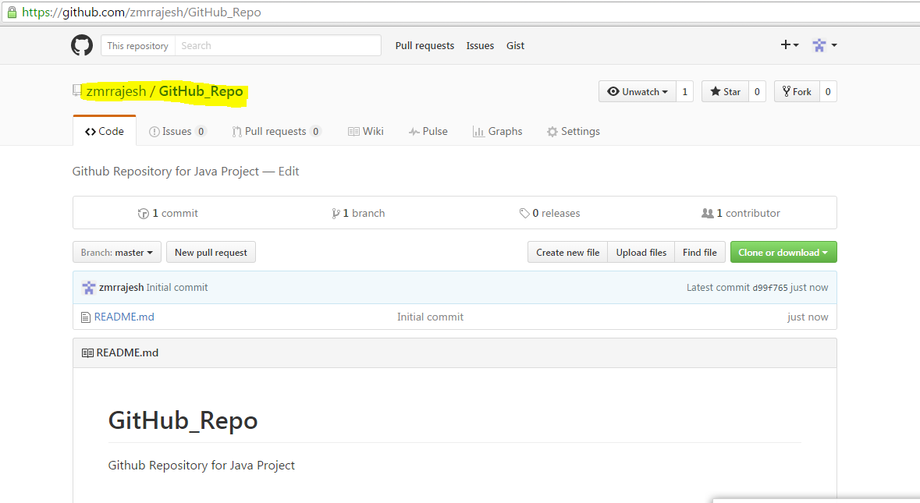
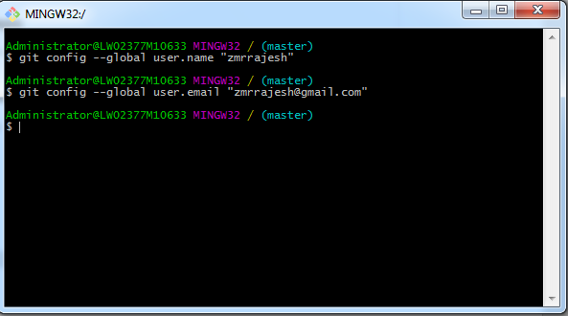
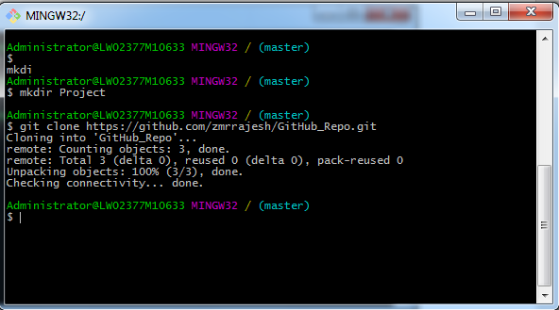
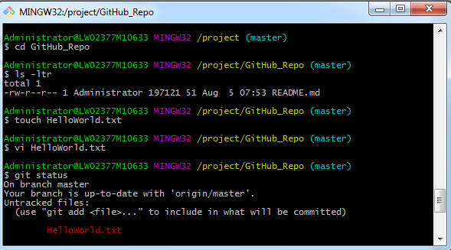
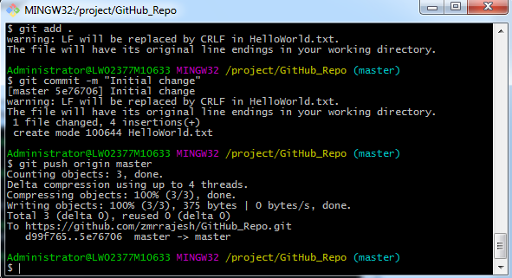
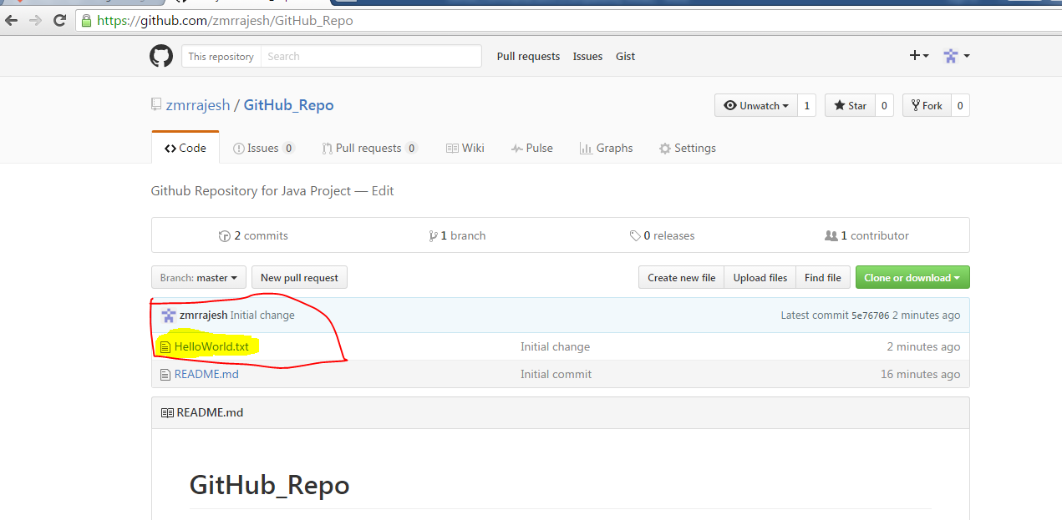
Go to site
https://git-scm.com/downloads

Click on Windows
Required file is

Click on Git-2.9.2-32-bit.ext

Click on Next

Click on Install

Login to github site

https://github.com/

Sign in with user name and password
Click on New Repository

Click on Create Repository
Once Repository is created go back to bash shell
Fire following commands
git config –global user.name “zmrrajesh”
git config –global user.email zmrrajesh@gmail.com

Clone github repository to local directory
Mkdir project
Git clone https://github.com/zmrrajesh/GitHub_Repo.git
Cd GitHub_Repo
Touch HelloWorld.txt
Vi HelloWorld.txt ( write some thing ) create files
Or keep your project files any you want to push to Github site
Git status
Git add HelloWorld.txt or git add .
Git commit -m “Initial change”
Git push -u origin master

Got to Git Hub repository and refresh

